Email Spam Classifier – Detailed Project Report

Project Overview

With the ever-increasing digital communication, spam emails have become a significant concern, leading to security threats, phishing attacks, and loss of productivity. This project aims to implement an intelligent and automated solution Machine Learning (ML) techniques to classify emails as 'Spam' or 'Not Spam'. The user interface is designed using Streamlit to make the tool accessible and interactive. The system provides an efficient and user-friendly environment where any user can paste an email and instantly get a classification result.

Technologies Used

A comprehensive stack of technologies was used to implement, train, evaluate, and deploy the spam classifier:
- Python: Core programming language for logic, ML training, and backend integration.
- Streamlit: Lightweight Python library for building web applications, providing fast and interactive UI.
- NLTK (Natural Language Toolkit): Used for tokenization, stopword removal, and stemming. It provides robust NLP tools essential for text preprocessing.
- Scikit-learn: Machine Learning library used for model training, evaluation, and vectorization using TF-IDF.
- Pickle: Python library used to serialize (save) trained models and vectorizers.
- Jupyter Notebook: Used for code development, experimentation, visualization, and comparative model evaluation.
- Matplotlib / Seaborn: (Optional for future use) Useful for visualizations like accuracy comparisons.

3. Text Preprocessing in NLP

Preprocessing raw email content is vital for ensuring the effectiveness of machine learning models. The steps include:
1. Lowercasing: All text is converted to lowercase to reduce the dimensionality of the data. For example, 'Free' and 'free' should be treated the same.
2. Tokenization: Splitting the email into individual words using `TreebankWordTokenizer`, which handles contractions and punctuation well.
3. Special Character Removal: Removes digits and symbols using `isalnum()` to focus on meaningful words.
4. Stopword Removal: Removes commonly used English words (e.g., 'the', 'is', 'in') using NLTK’s stopwords, as they provide minimal contribution to classification.
5. Stemming: The PorterStemmer reduces words to their root form (e.g., 'running', 'runs', 'ran' → 'run'). This reduces complexity and standardizes word usage.

4. Machine Learning Models Evaluated

Several classification algorithms were trained and evaluated using the same dataset split (train-test) and TF-IDF vectorization:
- Gaussian Naive Bayes: Assumes a normal distribution. Not ideal for sparse data and performed poorly.
- Multinomial Naive Bayes: Designed for word counts and document classification; showed decent performance.
- Bernoulli Naive Bayes: Best suited for binary/boolean features (word present or not). Excelled in performance.
- Support Vector Classifier (SVC): A margin-based classifier. Works well in high-dimensional space but took more time.
- Logistic Regression: Linear classifier that performed well but slightly underperformed BernoulliNB.
- Random Forest Classifier: Ensemble model with high accuracy but more computational cost.
- Decision Tree Classifier: Simple to interpret but prone to overfitting.

5. Why Bernoulli Naive Bayes Performed Best

Bernoulli Naive Bayes outperformed others primarily because it assumes binary features, which align closely with the TF-IDF representation of emails (word exists vs. not). This model is especially effective in scenarios where absence of a word is as important as its presence. Its simplicity and low computation time made it ideal for real-time classification. Research supports its performance in binary text classification tasks.

6. Shortcomings of the Current Model

- Over-reliance on word presence: Cannot handle contextual or semantic meaning.
- Simple preprocessing: Stemming can remove necessary word distinctions.
- No context understanding: Cannot detect advanced spam with hidden meanings or images.
- Fixed vocabulary: Unknown words during inference are ignored.
- Static model: Requires retraining for adapting to new types of spam.

7. Future Technologies and Enhancements

- Lemmatization instead of stemming to better retain semantic meaning.
- Transformer models (like BERT, RoBERTa): For deeper contextual understanding of messages.
- Active learning: Incorporating user feedback to update and improve model continuously.
- Use of word embeddings like Word2Vec or GloVe instead of TF-IDF for improved text representation.
- Multilingual Support for broader coverage of spam emails.

8. Model Accuracy Chart

Below is a comparative performance of the evaluated models based on test accuracy:

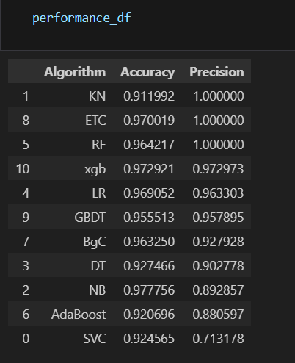
[Fig 1] Accuracy and Precision Score Table for different ML Models

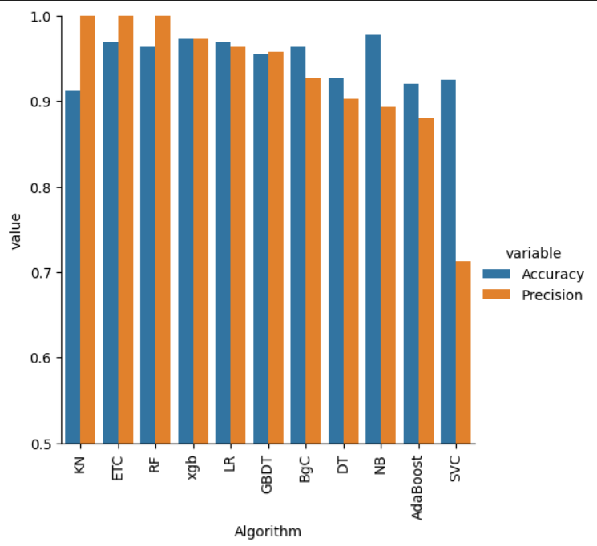

[ Fig 2] Visualization of Accuracy and Precision Score of different ML Models

